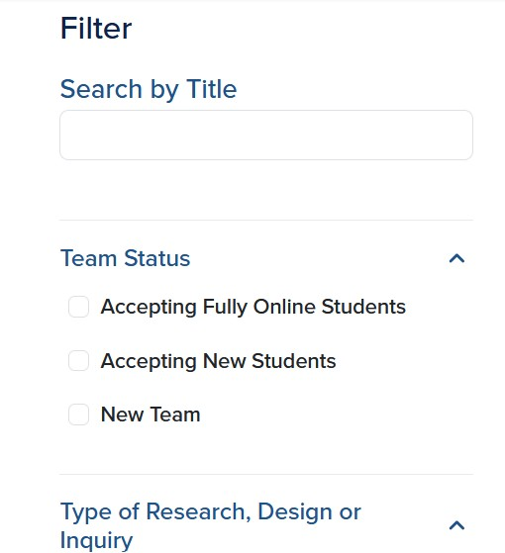
VIP Research, Inquiry & Creative Activities Teams Now Accepting Fully Online Students: https://uavip.arizona.edu/find-right-team-you
Team’s name below links to their VIP website (team’s type of inquiry)
AI in Healthcare Simulation Education and Training (Engineering or Technology, Medicine/Human Health)

The AI in Healthcare Simulation Education and Training team builds smart learning tools for future clinicians: virtual patients you can actually talk to, AI that scores your interviews or sutures, and dashboards that make feedback instant and clear. The Arizona Simulation Technology & Education Center (ASTEC) is our high-tech home base, but our focus is on the AI projects shown on our website. Led by Winslow Burleson, PhD, and Allan Hamilton, MD, FACS.
Co-Design Collaborative (Co-Lab) (Humanities, Social and Behavioral Sciences)
The Co-Design Collaborative (Co-Lab) VIP team works alongside organizations and communities in seeking to answer the question: How can we design more equitable and inclusive spaces for participation? The team will collaborate on projects related to reimagining the processes by which we organize to make progress on adaptive challenges facing our communities (e.g., racial and gender inequities, peace and security, food justice). Current projects include the #ShiftThePower Project, the College Student Hunger Project, and the Cultivating Food System Resilience Project. Led by Dr. Jasmine R. Linabary, PhD.
Food Safety and One Health (Agriculture, Life & Environmental Sciences)
The Food Safety and One Health VIP Team aims to assess the prevalence of enteric pathogens that impact the safety of our food supply, through the lens of One Health. The approach recognizes the interconnectedness between human health, animal health, and the environment to take into account all of the factors that may influence the presence of pathogens in our food supply. Led by Margarethe Cooper, PhD.
Horizon Collective: Where Research Meets Community to Improve Mental Wellbeing (Medicine/Human Health)
The goal of the Horizon Collective: Where Research Meets Community to Improve Mental Wellbeing VIP is to engage students in interdisciplinary, community-engaged research and action to understand, prevent, and reduce youth mental health challenges in Tucson, Arizona, while promoting resilience and mental well-being. Led by Alexandra Restrepo-Heano, MD, MSc, PhD.
Water Whys (Environment and Resilience, Fine Arts or Data Visualization, Science)
The Water Whys team creates scientifically accurate and easy-to-understand graphical answers to water questions. Our graphics are used by TV meteorologists and reporters to help their audiences better understand current events impacting their communities and their lives. What we create is seen by thousands of people each year. VIP students work collaboratively to learn what it takes to make scientifically accurate, visually effective and accessible communication graphics geared toward a diverse and multi-lingual public. Led by Laura Condon, PhD, Sara Kobilka, MS, and Ryan Hunt.

